WiFi System Matlab Simulation Instruction

**V3.6 Structure**

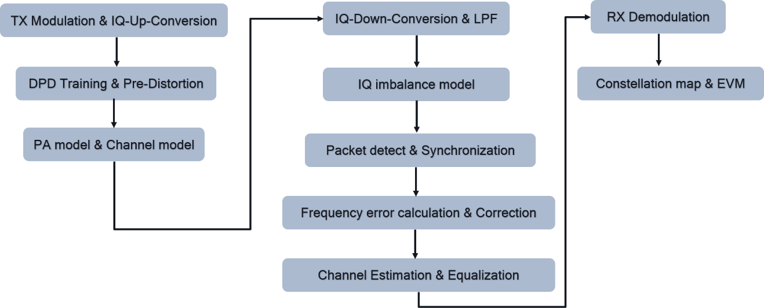

1. Introduction

• The entire code of the simulation program, as below figure.

‘Main.m’ file is the main-function of program and please set user defined parameters and run the entire simulation program in this file.

The other ‘.m’ files is the sub-function which will be called by the main-function.

Please refer to ‘Version_Info & Instruction’ folder to get this file and version info.

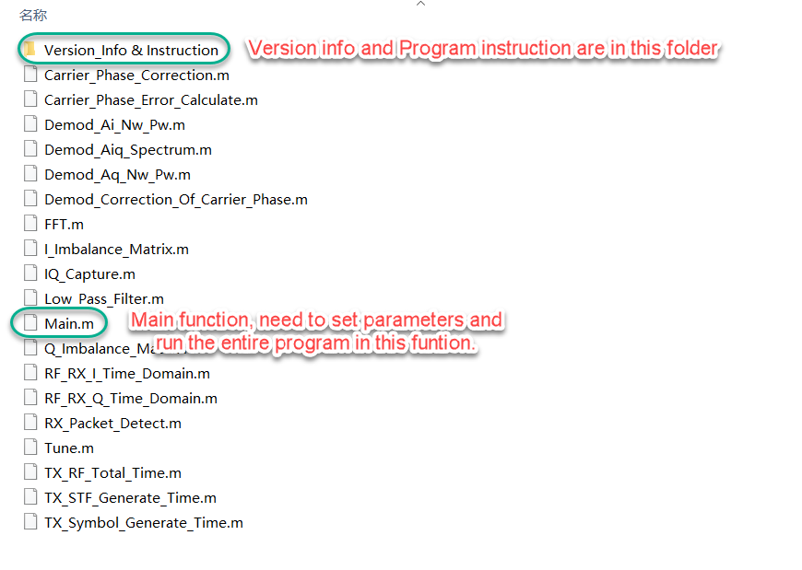

2. User Guide

• Please find the entire Matlab window below.

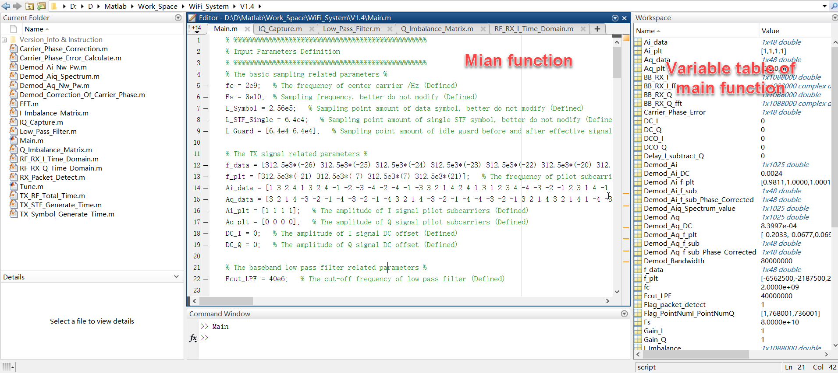

• The user defined parameters in main-function, please find the detail description in the annotation of each item.

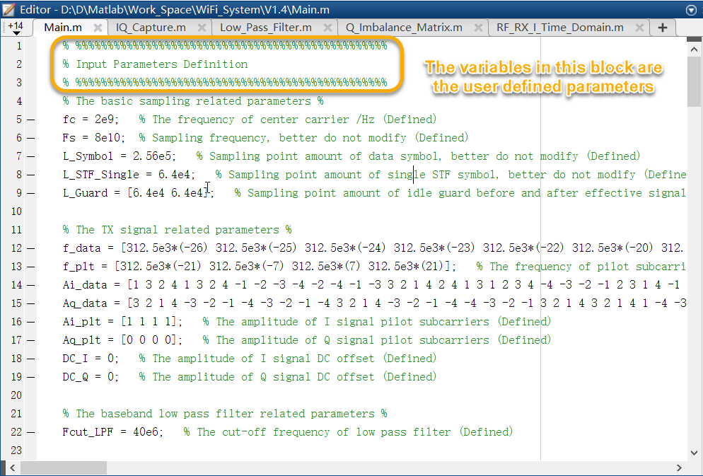

3. Structure of program

1> TX RF signal implement

Create a complete RF TX signal including 10 STF symbols, 1 data symbol, guard-interval(GI) and cycle-prefix(CP).

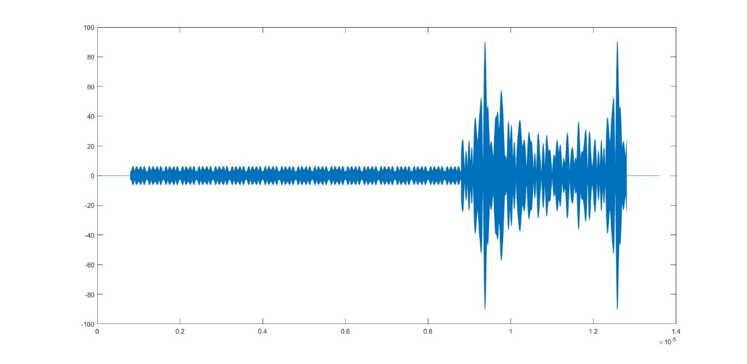

Figure. Generated TX RF signal (Time domain)

2> RX RF down-conversion implement

Down-conversion of received signal, received signal is TX signal has been generated before.

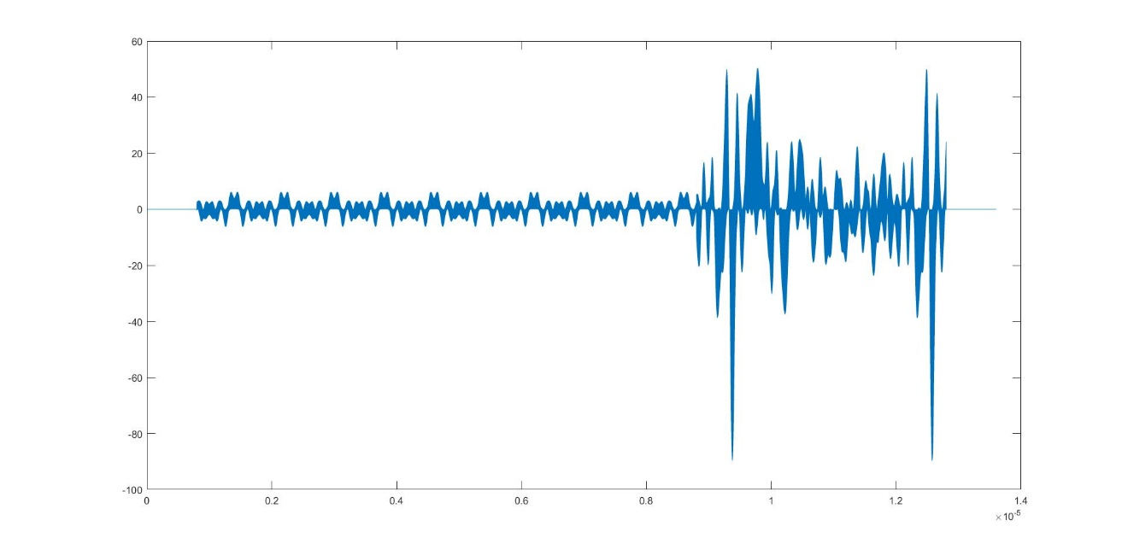

Figure. Signal after down-conversion of I path (Time domain)

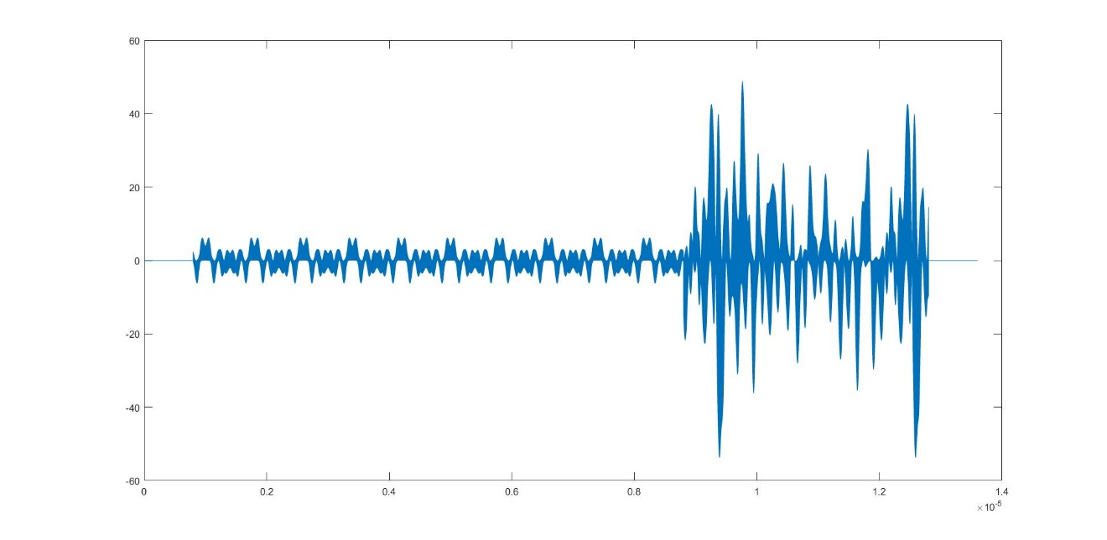

Figure. Signal after down-conversion of Q path (Time domain)

3> RX baseband Low-pass-filter implement

Achieve an ideal low-pass-filter of BB section which is used to filter the high frequency component after down-conversion.

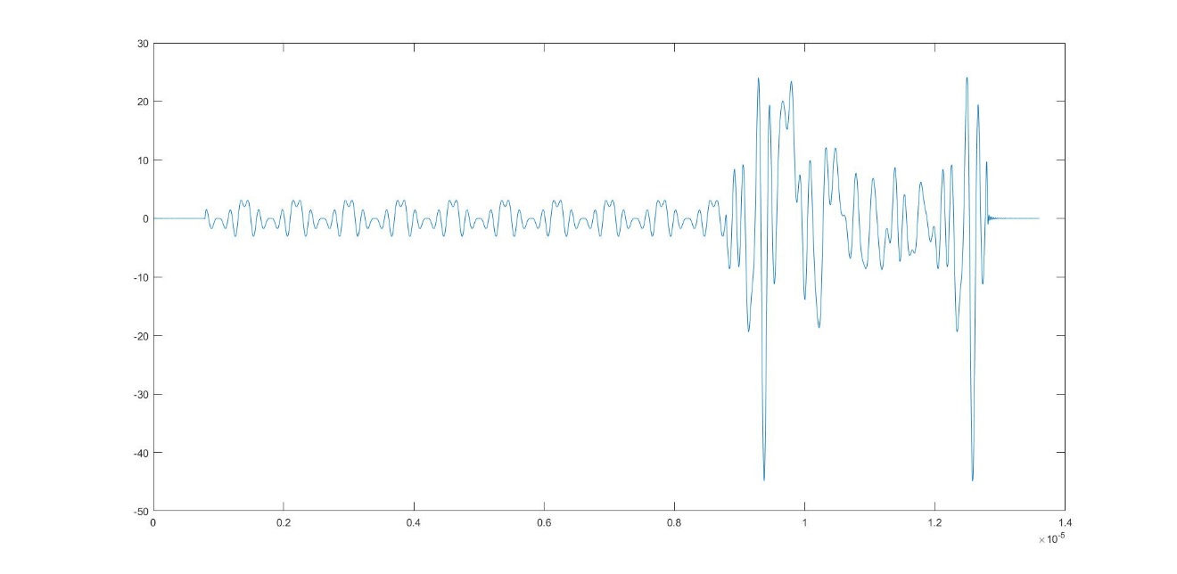

Figure. Signal after low-pass-filter of I path (Time domain)

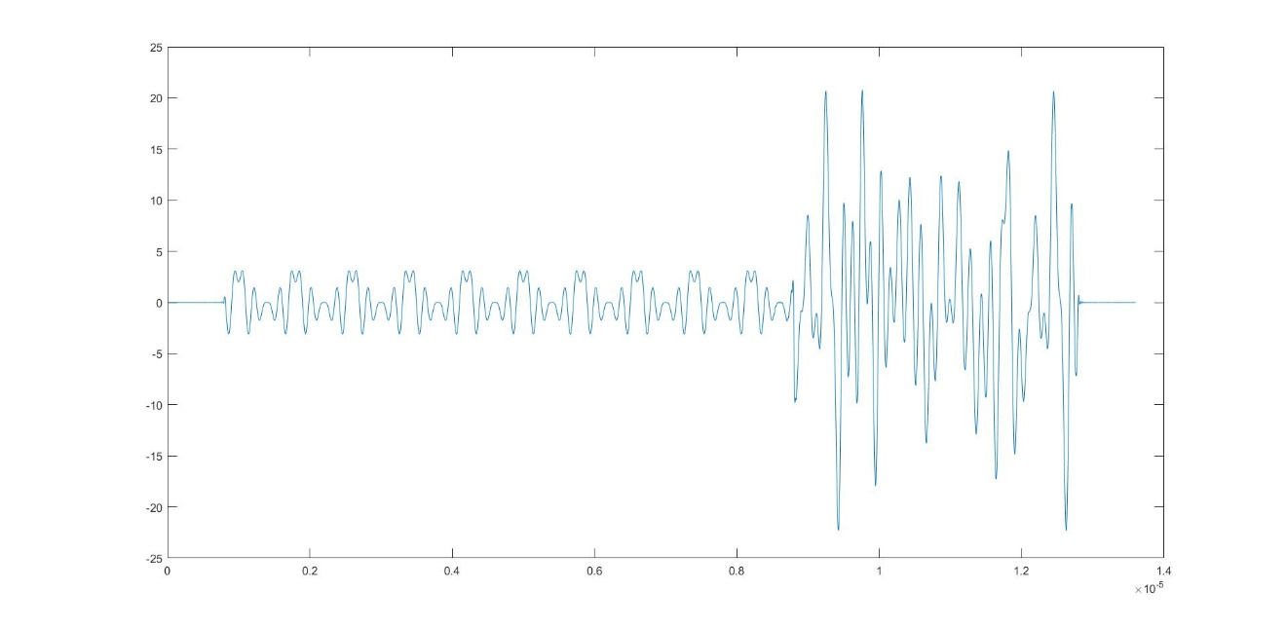

Figure. Signal after low-pass-filter of Q path (Time domain)

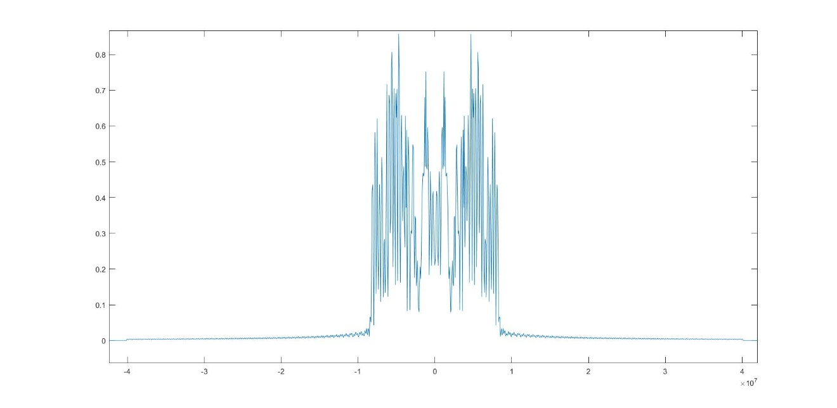

Figure. Signal after low-pass-filter of I path (Frequency domain)

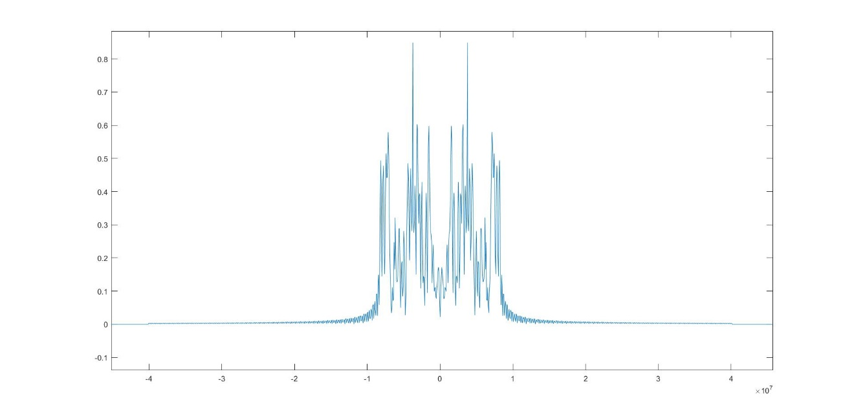

Figure. Signal after low-pass-filter of Q path (Frequency domain)

4> RX baseband I/Q imbalance matrix implement

Achieve the I/Q imbalance including DCO, Gain imbalance, Time delay imbalance.

5> IQ Capture of entire received signal

Achieve IQ capture feature, this is similar with the ‘IQ Capture’ in QRCT3.

Can select three types of FFT window including Rectangular, Hanning, Bartlett.

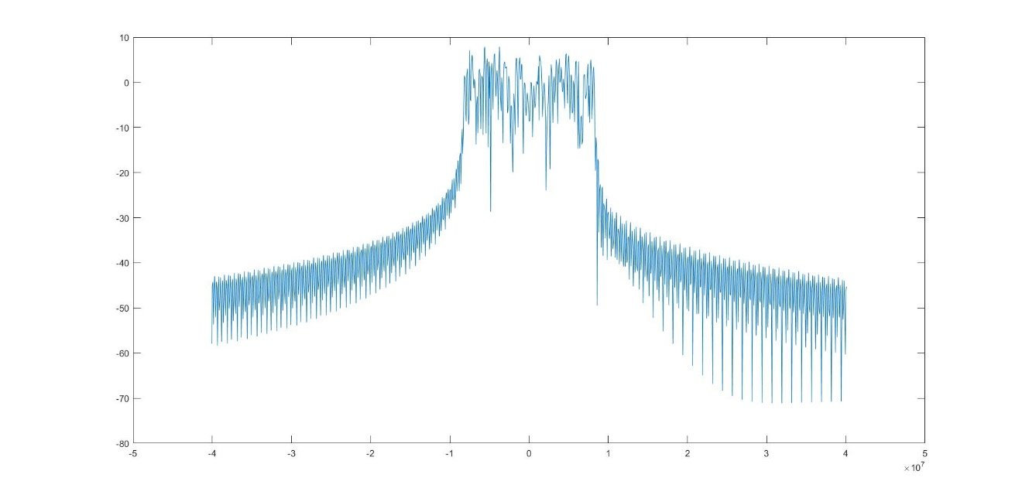

Figure. Rectangular window (Frequency domain)

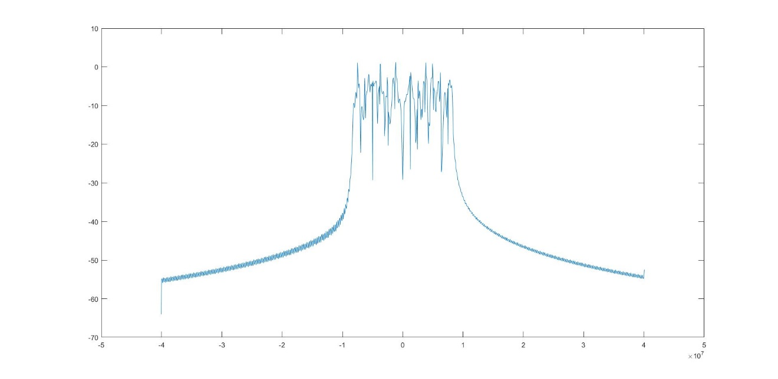

Figure. Hanning window (Frequency domain)

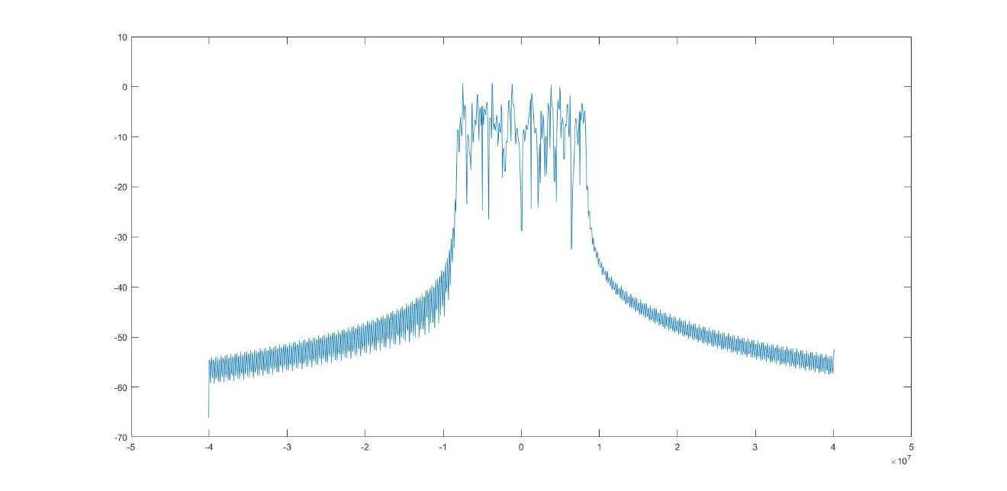

Figure. Bartlett window (Frequency domain)

6> RX packet detect implement

Detect if there is a WiFi packet in the entire received signal by using 10 STF symbols.

Intercept signal whose length is correspond to 11 STF symbols and 1 STF symbol; correlation with these two intercepted signals.

If there are at least 10 peaks that the interval of each other is about 1 STF symbol length in correlation result, then deems there is a WiFi packet in received signal; if not, continue looping until detect it or run out the received signal.

Use the info that detect the WiFi signal for data symbol synchronization with a little forward offset to ensure the FFT window not exceed CP and data symbol domain.

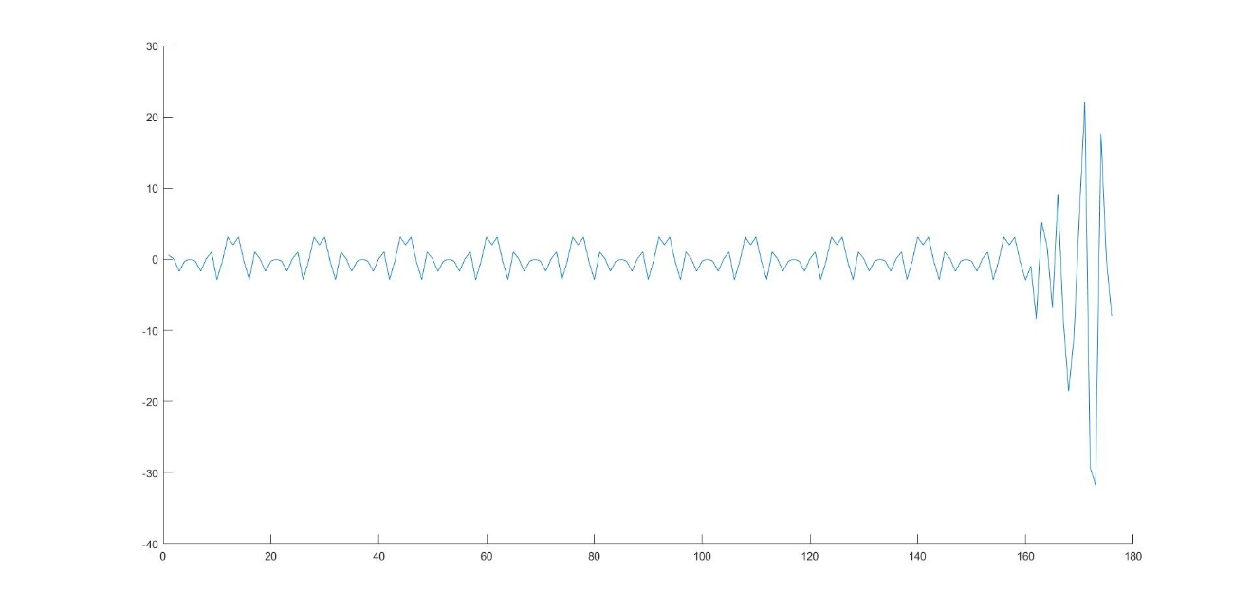

Figure. STF symbols after synchronization of I path

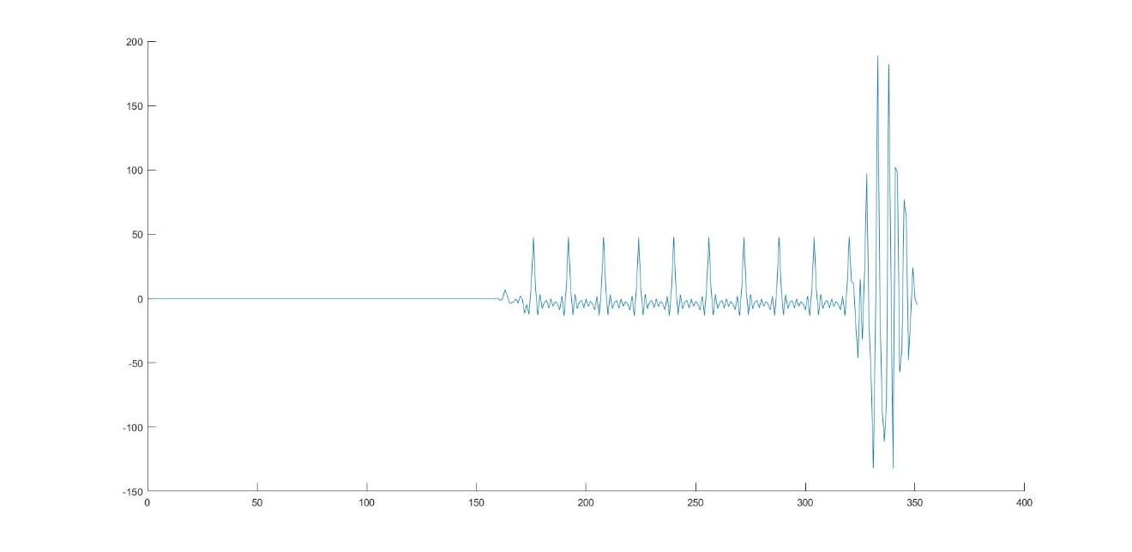

Figure. Correlation result of STF

7> Intercept the data symbol after synchronization

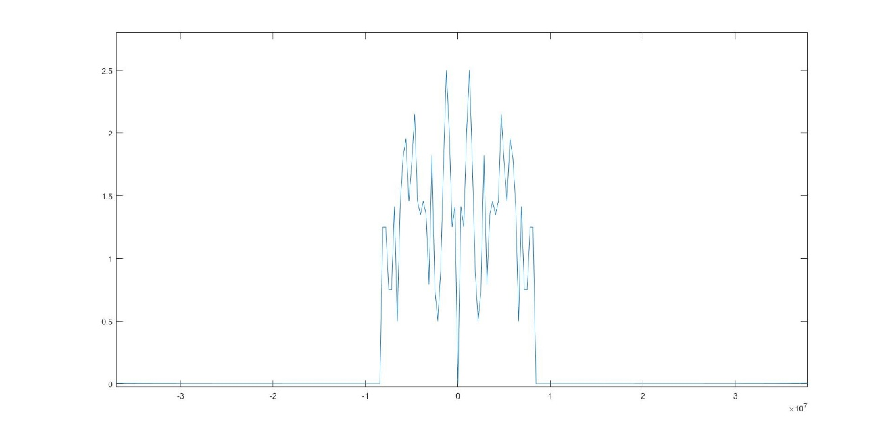

Figure. Imbalanced data symbol of I path (Frequency domain)

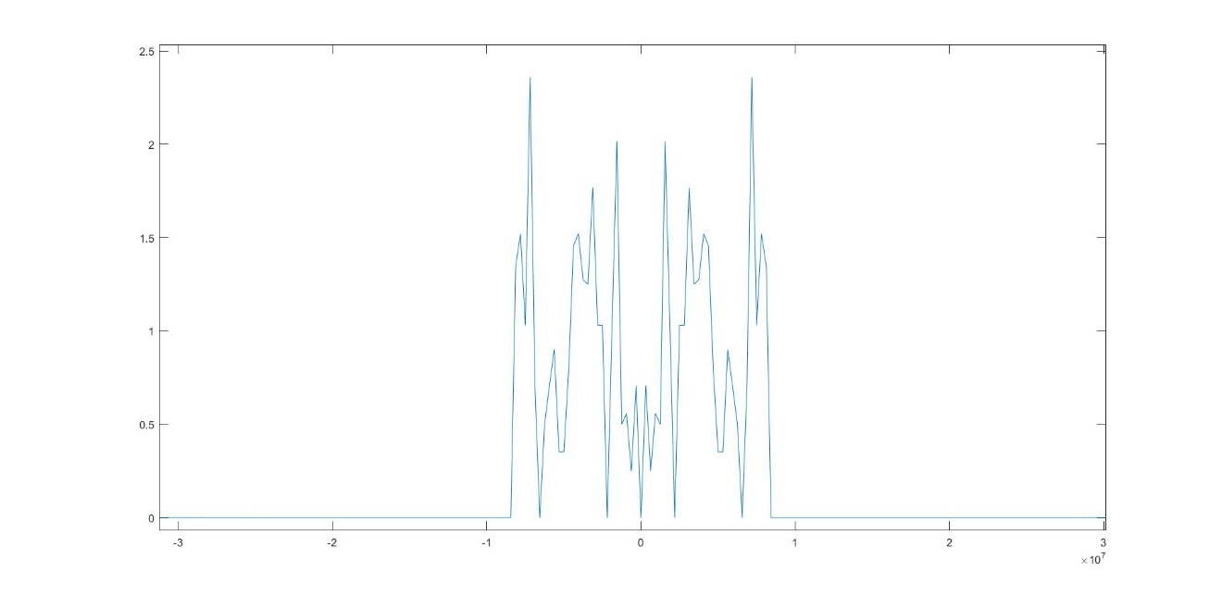

Figure. Imbalanced data symbol of Q path (Frequency domain)

8> RX baseband de-modulation and pick the de-modulation results

The initial de-modulation result as below, each value correspond to one data sub-carrier.

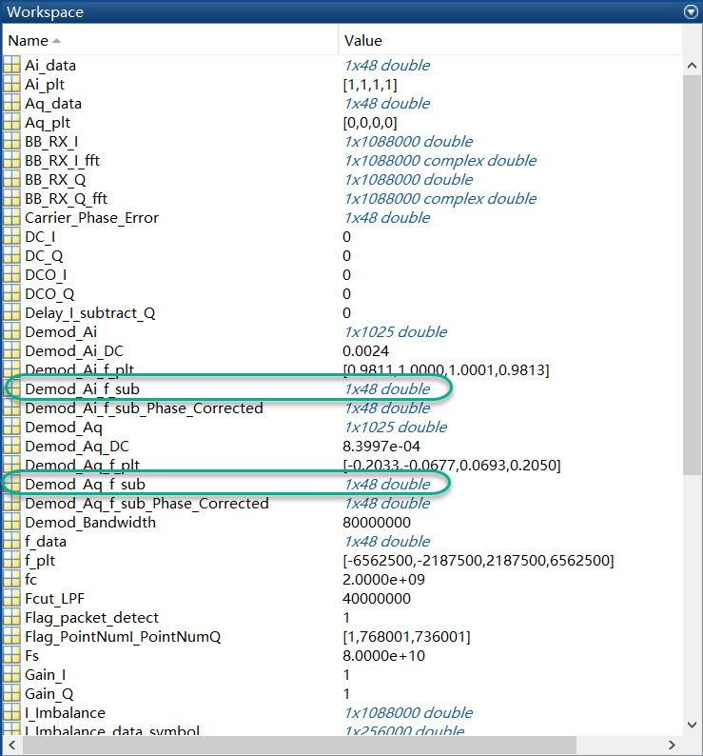

Figure. Initial de-modulation result

9> Phase correction implement

Correct the phase error caused by the error of synchronization; estimate the phase error of each data sub-carrier by using the linear fitting result of pilot sub-carriers.

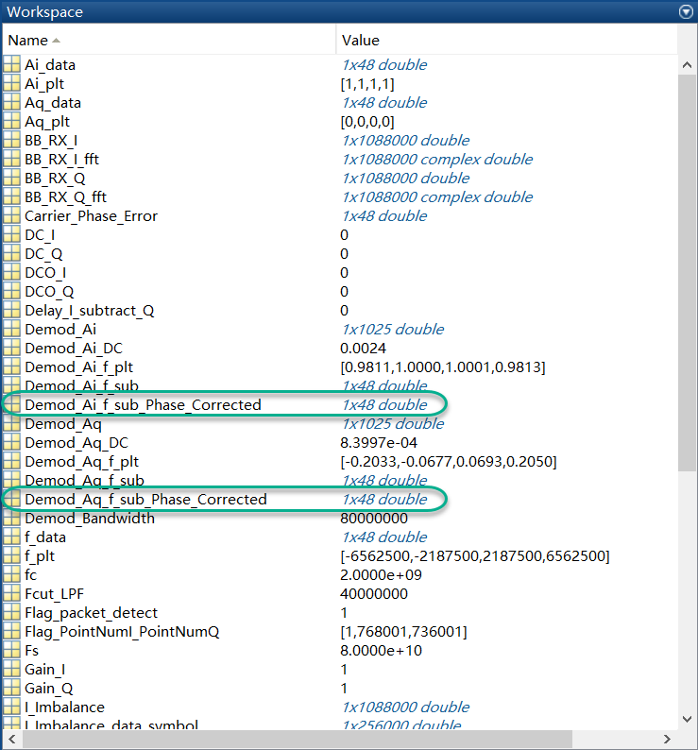

Figure. De-modulation result after phase correction